ALL TEST 6.31 Analysis Results

Performance Summary

Bottom Line
This induction motor is operating normally, no action is required.
X This induction motor exhibits suspicious operation, trending of the induction motor is warranted.
This induction motor exhibits abnormal indications, action is warranted, NOW.

Power Factor Commentary
Power factor exceeds 0.85.
X Power factor is below 0.85, see detailed report.

Current Commentary
X Current variation is within normal limits.
Current variation is beyond normal limits, see detailed report.

Voltage Commentary
X Voltage variation is within normal limits.
Voltage variation is beyond normal limits, see detailed report.
RMS voltage differs from nameplate by more than 5%.

Load Commentary
X Load on the induction motor is consistent with nameplate values.
Load on the induction motor exceeds nameplate values, see detailed report.
Load on the induction motor is less than 25%.

Phase Connection Commentary
X Connections are normal.
Voltage ground reference is NOT neutral.
Loose connection.

Rotor Commentary
Rotor bar health is normal.
X Rotor bar health is questionable, see detailed report.
Load is insufficient to determine rotor bar health, at this time.

Stator Commentary
X Stator health is normal.
Stator mechanical health is questionable. .
Turn to turn short.

Rotor/Stator Air-gap Characteristics
X Dynamic or static eccentricity indications do not exist.
Indications of static eccentricity exist .
Indications of dynamic eccentricity exist.

Harmonic Distortion Commentary
X There is no evidence of harmonic distortion.
There is evidence of harmonic distortion, see detailed report.

Misalignment Indications
X There are no indications of mechanical problems like misalignment or unbalance.
There are indications of mechanical problems like misalignment / unbalance. Perform vibr. survey to identify and correct the cause.

INPUT SUMMARY

NAMEPLATE INFORMATION
 |  | Units
Serial Number | JB/18680-2008
Model Number | Y2-250-6
Tested Equipment | Induction
Power | 49.60 | HP
RPM | 980.0 | Rpm
Poles | 6
Phases: | 3
Voltage | 380.0 | Volt
Full Load Current | 70.70 | Amp
No Load Current | 3.00 | Amp
Number of rotor bars | 58
Number of stator slots | -1
Torque | 265.7 | Ft.Lb
CT Ratio | 1.000
Service Factor | 115
Motor efficiency | -1.000
Power factor | 0.860

Description:
Belum ada data rotor bar dan stator slot

LEGENDS:
Impedance | = Complex Impedance = vi/ci
CF | = Crest Factor = (waveform peak)/(waveform rms)
VDF | = Transformer Harmonic De-rating Factor = sqrt(2)/CF, %

Slip % | = SRSS sum of slip and harmonic "levels" divided by RMS level of RMS DEMOD spectra between 0 and 65 Hz.
Upper sb | = dB level of upper slip sideband of power line peak
Lower sb | = dB level of lower slip sideband of power line peak
Se, fund | = Location of pole pass frequency fundamental, Hz
Se, harm | = Number of pole pass frequency harmonics
Rotor bar health | = Estimate of the percent of broken or cracked rotor bars
RB Hlt Index | = Rotor bar health index

THDF | = Voltage De-rating Factor = 100 - (voltage unbalance, %)^2, %
Level | = Sum of spectral amplitudes of pole pass frequency fundamentals and harmonics
Thd | = Total harmonic distortion
+Ve | = Positive sequence harmonic
-Ve | = Negative sequence harmonic
Zero | = Zero sequence harmonic

Detailed Calculations

Running Speed = 13.855 Hz [831 RPM]

Pole pass frequency = 16.479 Hz [989 RPM]

Load = 69.4 %
Time
 | RMS | Peak | CF
Current 1 | 52.100 | 75.267 | 1.445
Current 2 | 52.000 | 73.236 | 1.408
Current 3 | 51.900 | 73.236 | 1.411
Average | 52.000 | 73.913 | 1.421
% dev | 0.2 | 1.8 | 1.6

THDF = 99.5

Time
 | RMS | Peak | CF
Voltage 1 | 391.300 | 553.680 | 1.415
Voltage 2 | 391.400 | 552.830 | 1.412
Voltage 3 | 391.200 | 547.950 | 1.401
Average | 391.300 | 551.480 | 1.409
% dev | 0.0 | 0.6 | 0.6

VDF = 100.0

 |  |  | App. Power | Real Power | Reac. Power
 | Power factor | Impedance | kVA | kW | kVARS
Phase 1 | 0.798 | 7.511 | 11.759 | 9.380 | 7.091
Phase 2 | 0.795 | 7.527 | 11.757 | 9.350 | 7.128
Phase 3 | 0.797 | 7.538 | 11.719 | 9.340 | 7.078
Avg/Total | 0.797 | 7.525 | 35.235 | 28.070 | 21.298
% dev | 0.2 | 0.2

Demand Pwr = 37.63 HP

Load:69.4 %

Motor Eff.:91.7 %

Loss due to THD:

Output Pow.:25.44 KW

Output Trq.:215.39 Ft.Lb

Summary of Rotor Bar Health |  |  |  |  | Power line dB diff. |  | RB Hlt Index
 | Se, fund |  | Se, harm | Level % | Upper SB | Lower SB | RB Hlt Index
Measured | 16.479 |  | 3 | 0.2 | -56.315 | -53.771 | 0.333
Severity level |  | Rotor Condition Assessment |  |  | Recommended Corrective Action
3 |  | Slight indication of rotor problems |  |  | Continue surveys, trend only

Harmonic Distortion Results:
Voltage input, from 50.018 Hz harmonics
 | THD Odd % | THD Even % | +ve% | -ve % | Zero % | THD All %
Current 1 | 0.640 | 0.220 | 0.157 | 0.628 | 0.197 | 0.677
Current 2 | *** | *** | *** | *** | *** | 0.000
Current 3 | *** | *** | *** | *** | *** | 0.000
Voltage 1 | 0.780 | 0.100 | 0.133 | 0.771 | 0.084 | 0.787
Voltage 2 | *** | *** | *** | *** | *** | 0.000
Voltage 3 | *** | *** | *** | *** | *** | 0.000

Harmonic distortion table – Peak values, voltage is phase to ground
Hz | Cur1 | Vlt1 | Cur2 | Vlt2 | Cur3 | Vlt3
3000 | 74.2 | 315 | *** | *** | *** | ***
6000 | 0.2 | 0 | *** | *** | *** | ***
9000 | 0.1 | 0 | *** | *** | *** | ***
12000 | 0.0 | 0 | *** | *** | *** | ***
15000 | 0.4 | 2 | *** | *** | *** | ***
18000 | 0.0 | 0 | *** | *** | *** | ***
21000 | 0.1 | 0 | *** | *** | *** | ***
24000 | 0.0 | 0 | *** | *** | *** | ***
27000 | 0.0 | 0 | *** | *** | *** | ***
30000 | 0.0 | 0 | *** | *** | *** | ***
33000 | 0.1 | 0 | *** | *** | *** | ***
36000 | 0.0 | 0 | *** | *** | *** | ***

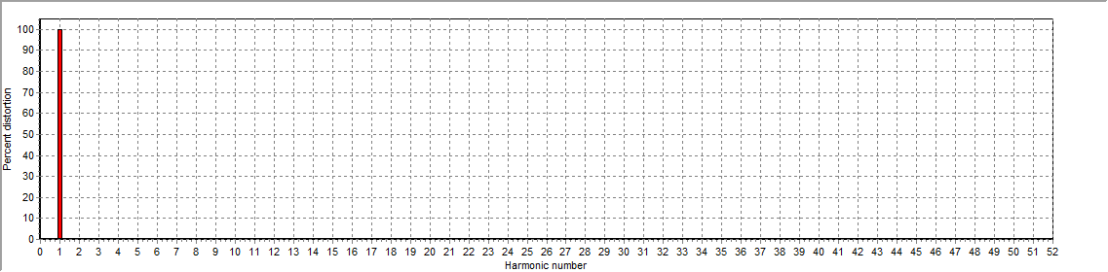
Figure 1: Current harmonic distortion plot

Figure 2: Voltage harmonic distortion plot

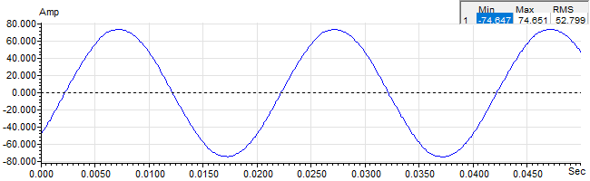
Figure 3: Raw Current

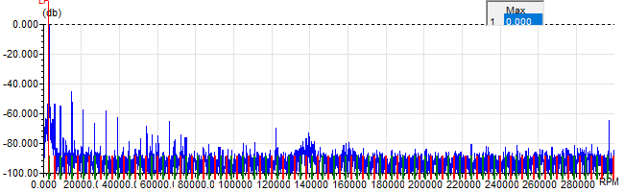
Figure 4: Raw Current Frequency spectrum

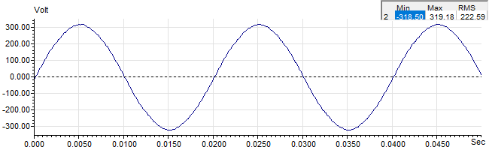
Figure 5: Raw Voltage

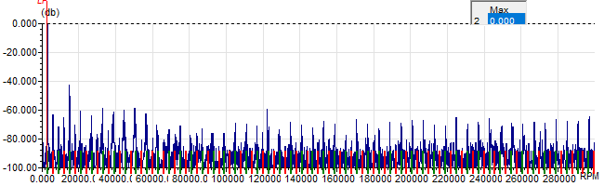
Figure 6: Raw Voltage Frequency spectrum

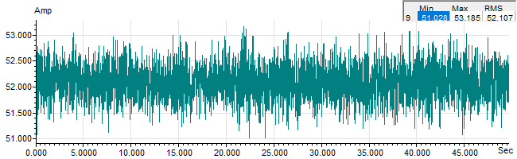
Figure 7: Demodulated current trace

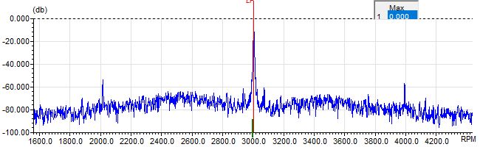
Figure 8: Raw current spectrum

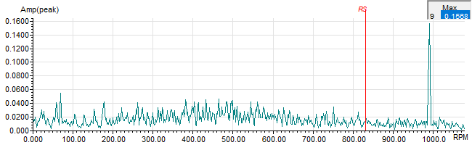
Figure 9: Demodulated current spectrum

